**Nieh flight mill wiring**

These are the details about the wiring of our flight mills. There are several small points that are important.

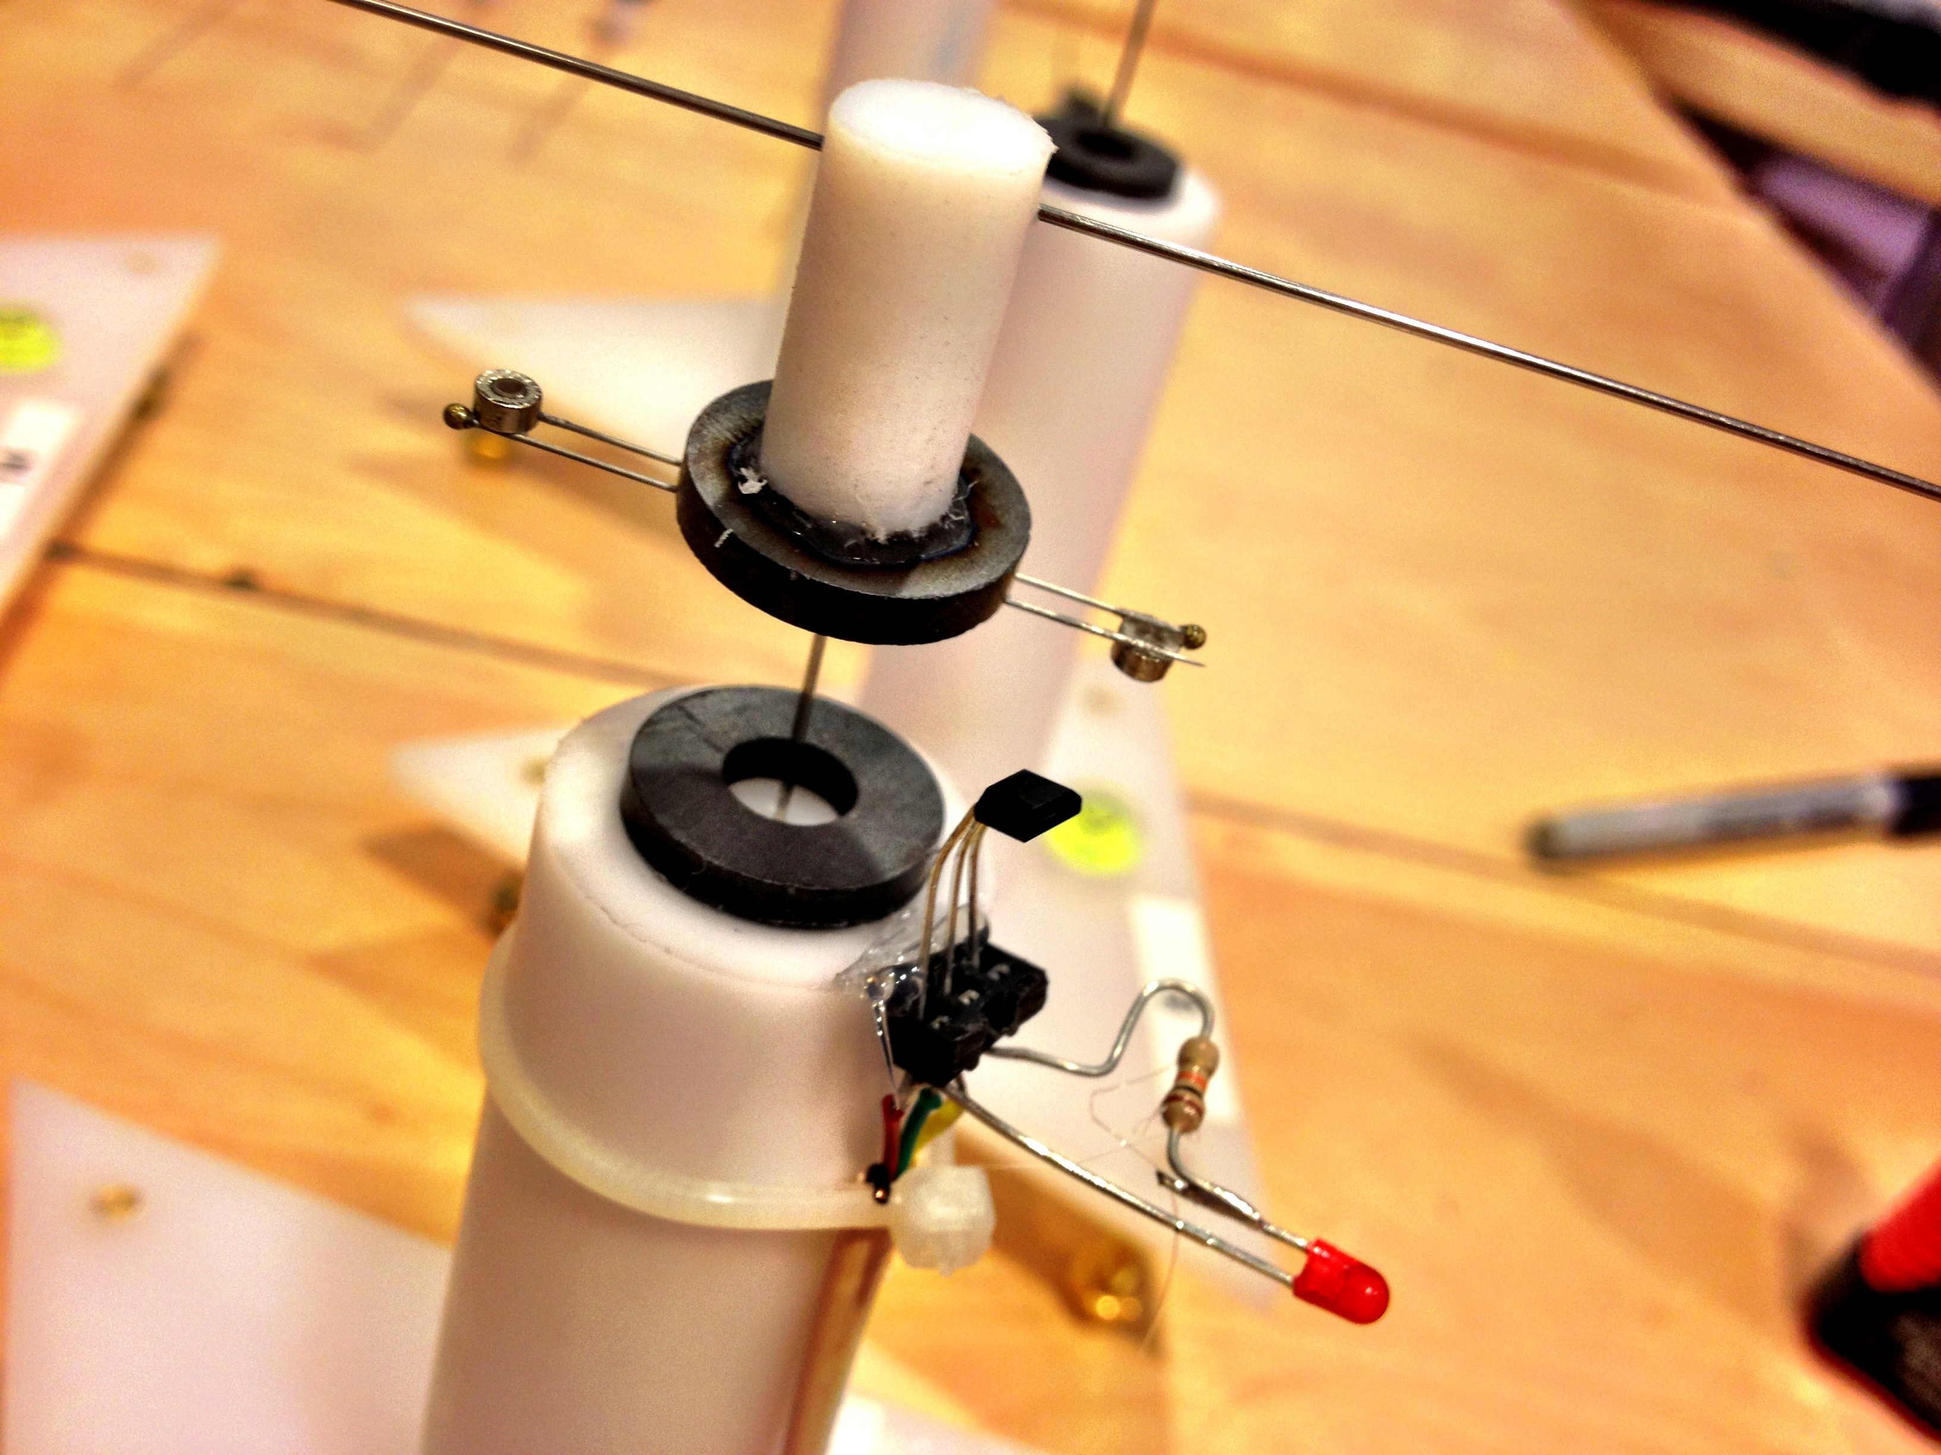

**Figure 1**. Here you see the assembled flight mill. Notice that the Hall Effect sensor has the **beveled side facing up**. This is the most sensitive side.

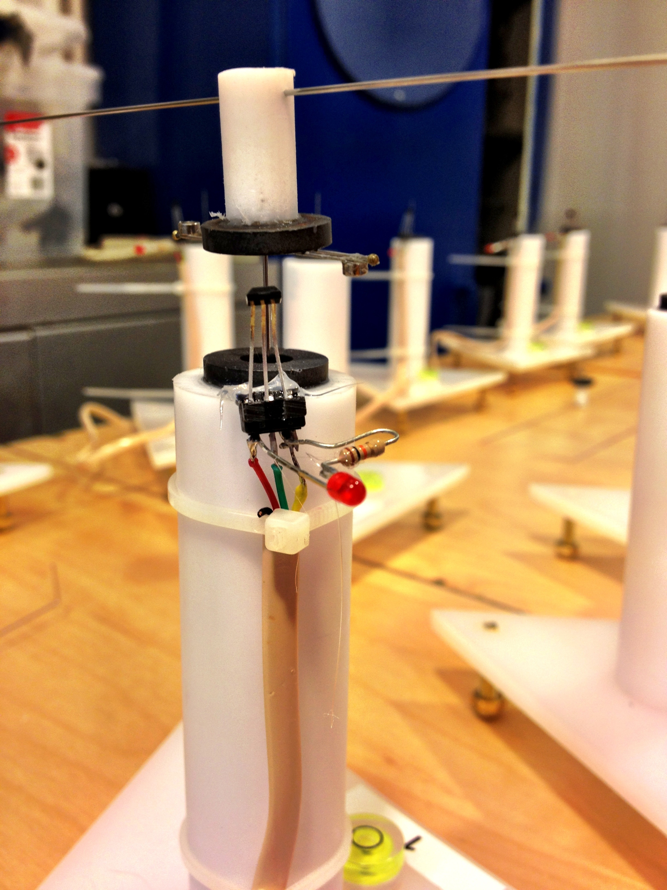

**Figure 2**. Notice the order of wiring. Left to right, it is red, green and yellow. The LED connection is on the red wire and the resistor connection is on the yellow wire.

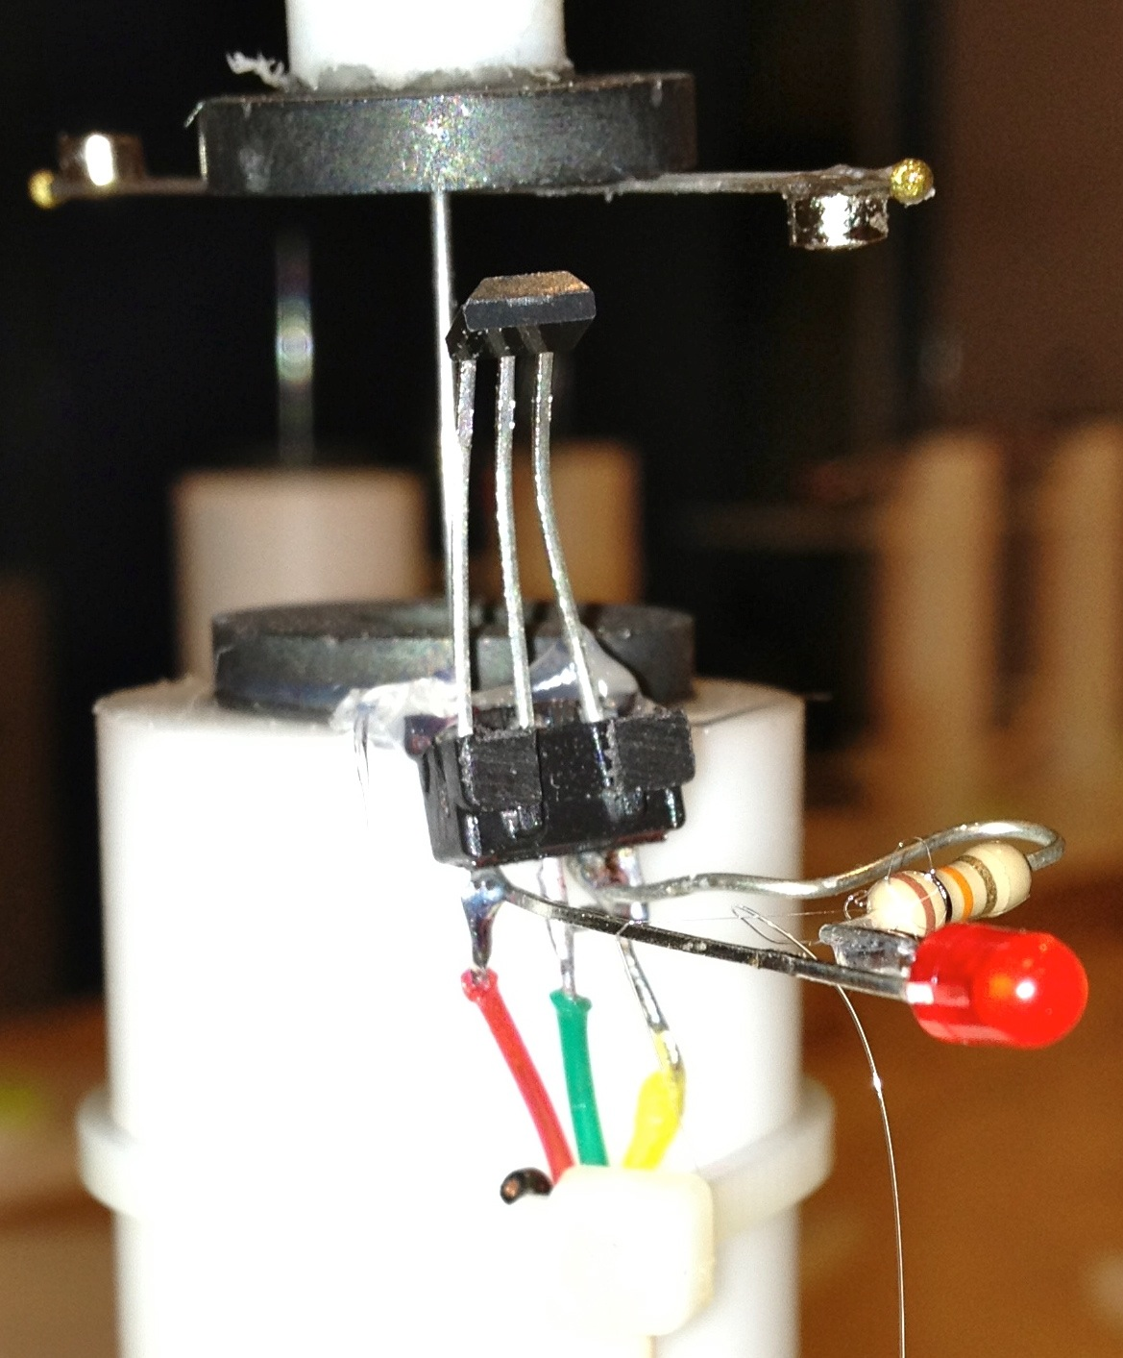

**Figure 3**. Notice the order of wiring. Left to right, it is red, green and yellow. The LED connection is on the red wire and the resistor connection is on the yellow wire. This also shows how the beveled side of the Hall Effect sensor is facing up. Make sure you test the IC mount after soldering to check for short circuits.

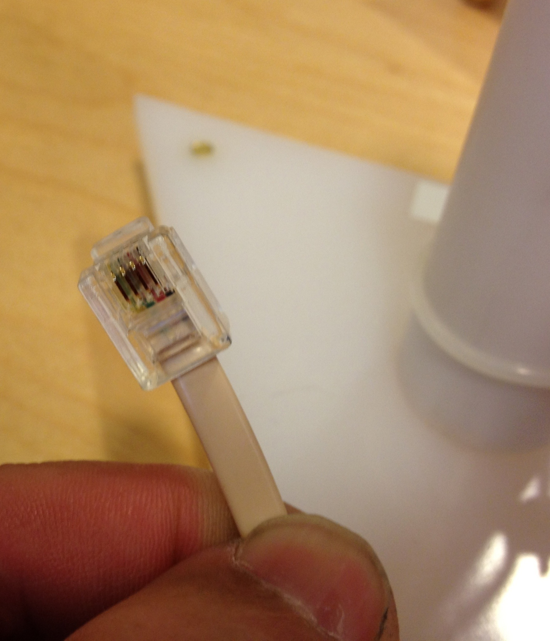

**Figure 4**. Each telephone cord line has two ends! The end that goes to the flight mill has wires in the following order (left to right): **yellow**, green, red, and black.

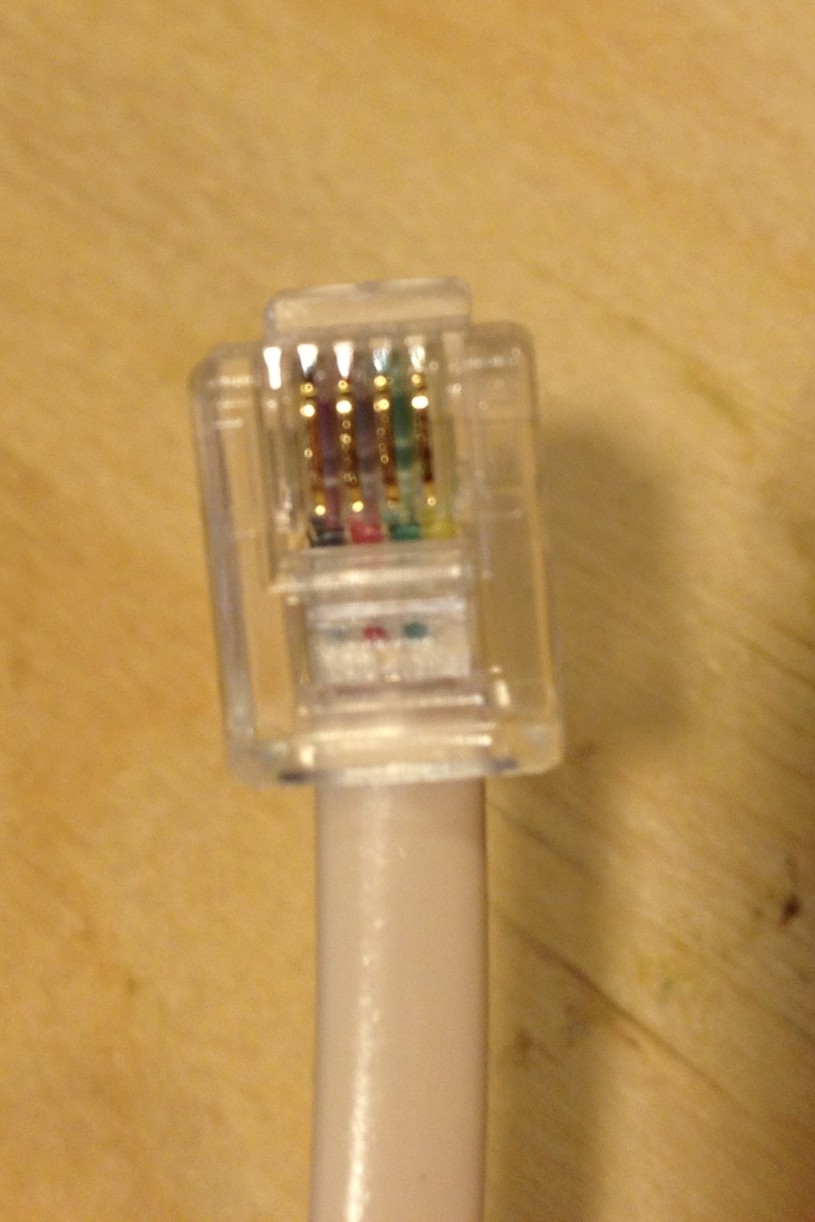

**Figure 5**. Each telephone cord line has two ends! This is the end that connects (via the female-to-female connector) to the flight mill. It has wires in the following order (left to right): **black**, red, green, yellow. It is a mirror image of the other connector.

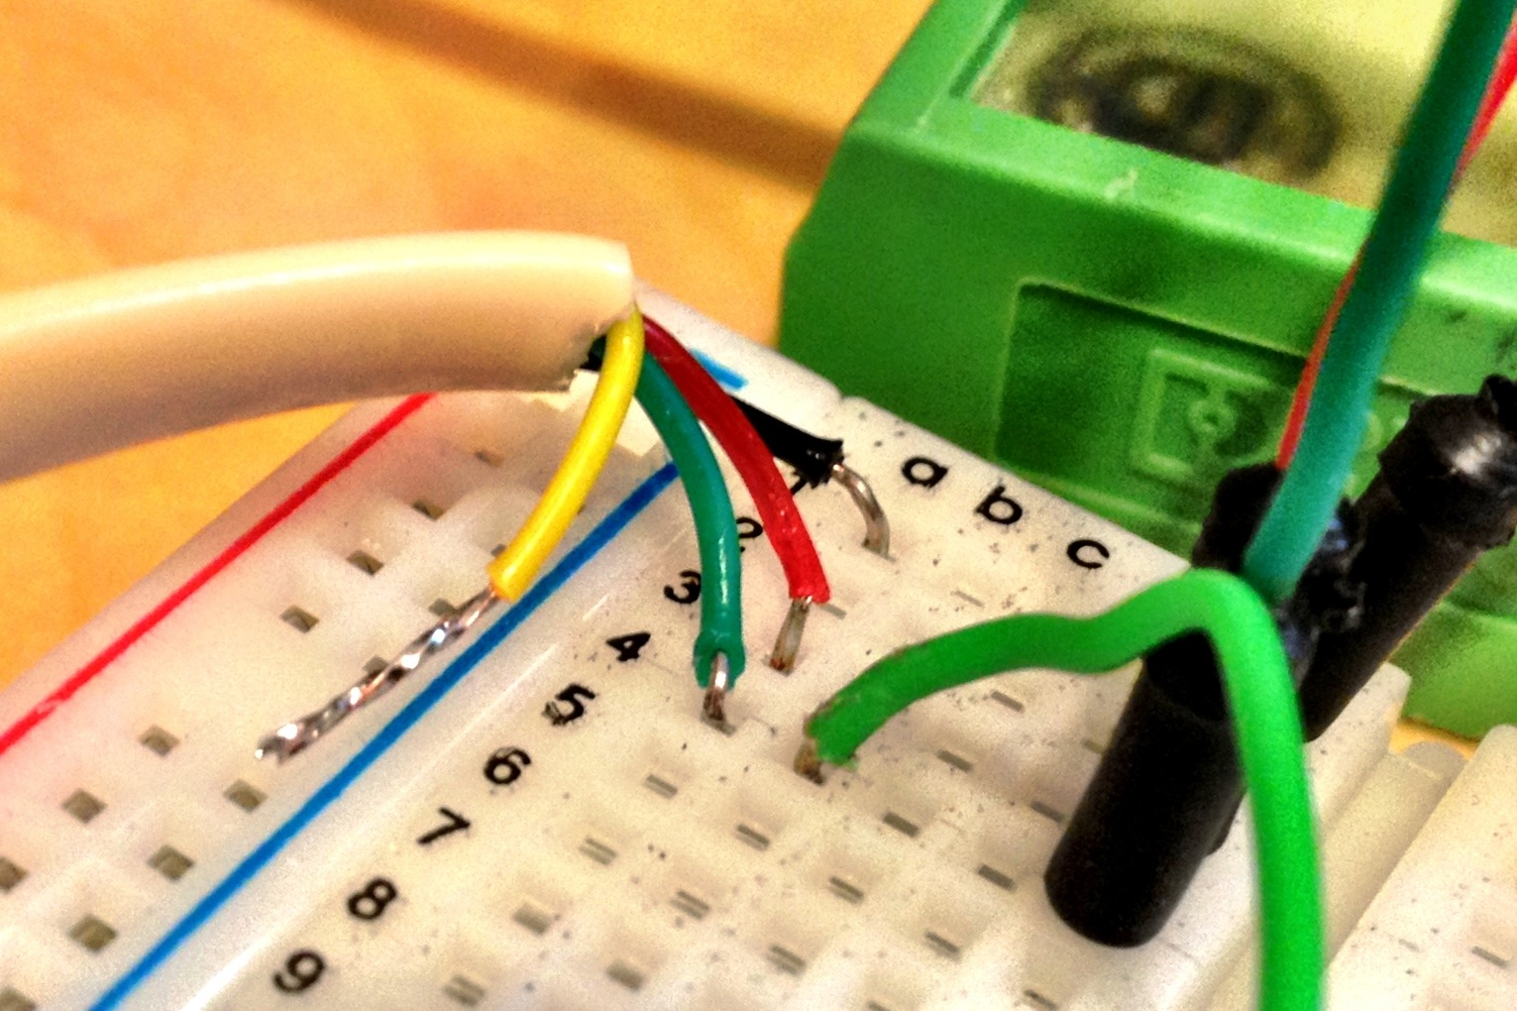

**Figure 6**. Going into the computer: **black** = +5V, **red** = ground, and **green** = signal. Yellow is not used.

If you map, one to one, what the wires connected to the sensor connect to when they reach the computer, they are as follows:

**Flight mill Computer** com Com

Yellow Black

Red Green

Green Red

Black Yellow

**On the computer card interface:**

slot 49 = +5V

all even numbered slots = ground

all odd numbered slots = signal

The ground and signals are organized in pairs. For example, (1,2), (3,4), (5,6), etc.

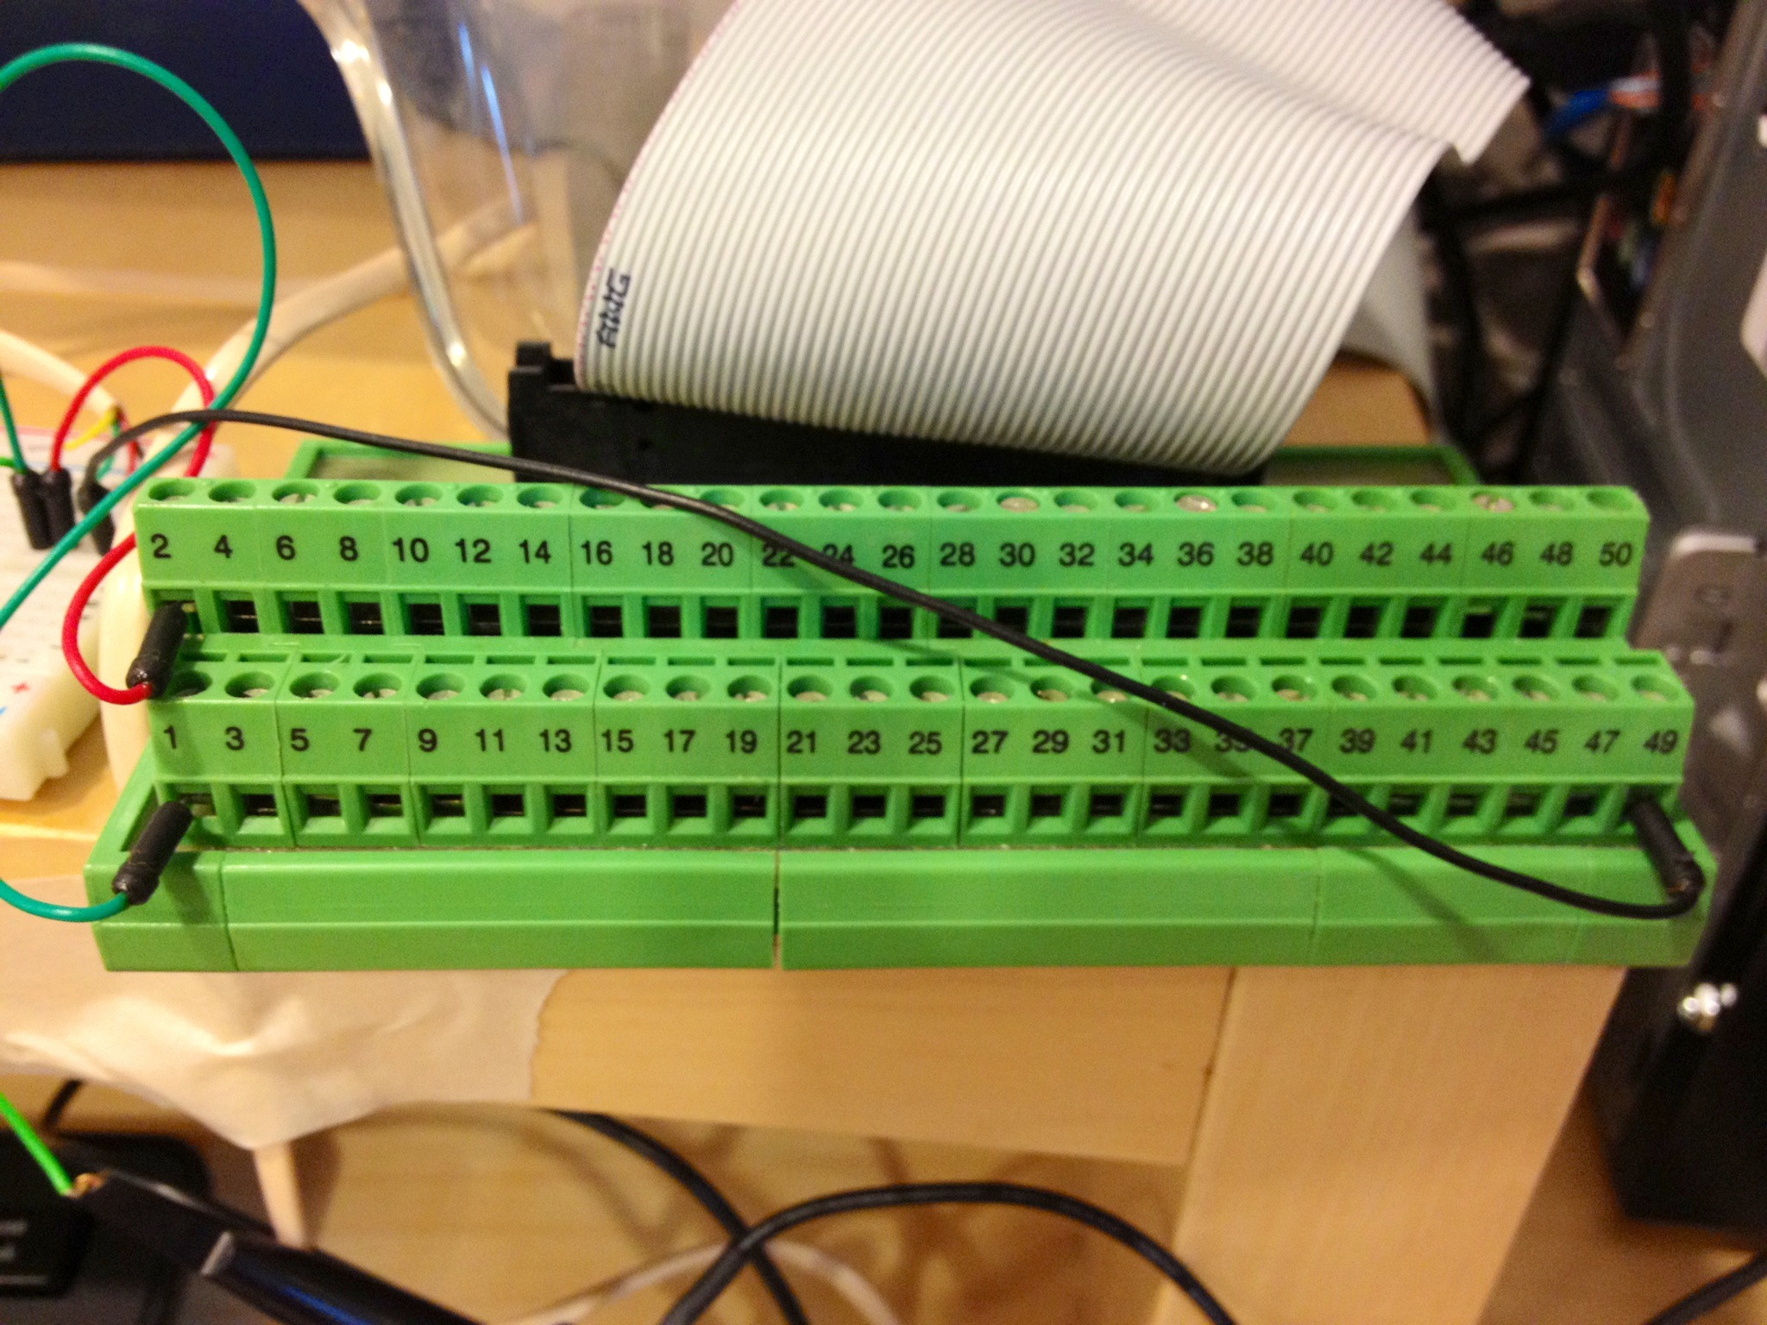

**Figure 7**. Computer card interface. Note that there is only one +5V output (slot 49). This will support a maximum of 24 mills simultaneously (in theory).